HireLens AI
Multi-Agent Job Rejection Analyzer
Hackathon Project Report



VACHAN U S
9886323678
vachanus@gmail.com

1. Abstract
The recruitment process has become increasingly automated with the use of Applicant Tracking Systems (ATS). Studies show that nearly 70–80% of resumes are rejected automatically before reaching human recruiters. Most candidates never understand why their applications fail, which prevents them from improving their resumes effectively.
HireLens AI is a full-stack AI application that simulates the hiring process using a multi-agent architecture. The system evaluates resumes using specialized AI agents that mimic real recruitment roles such as ATS screening, skills gap evaluation, experience assessment, and hiring manager decision-making. The application provides detailed insights including ATS compatibility scores, skills gap analysis, interview predictions, and a structured career improvement plan.
The platform is built using Python, Streamlit, CrewAI, and large language models (LLMs). By orchestrating multiple AI agents, the system delivers more accurate and structured analysis compared to single-prompt AI tools.

2. Problem Statement
Modern recruitment systems rely heavily on automation. Applicant Tracking Systems filter resumes based on keywords, formatting, and skill relevance before human recruiters evaluate them.
Key problems faced by job seekers include:
• Lack of feedback on rejected applications
• Difficulty understanding ATS requirements
• Poor alignment between resumes and job descriptions
• Limited guidance on improving resume quality
• Generic feedback from traditional resume tools
Existing resume analyzers provide surface-level suggestions but fail to simulate the real hiring pipeline.
Therefore, a system that replicates the hiring workflow and explains rejection reasons in detail is required.

3. Objectives
The primary objectives of the HireLens AI system are:
• Simulate the real recruitment pipeline using AI agents
• Analyze resumes against job descriptions
• Identify skill gaps and experience mismatches
• Provide structured resume improvement recommendations
• Predict recruiter shortlisting probability
• Generate actionable career development insights

4. Proposed Solution
HireLens AI introduces a multi-agent AI architecture that models the real hiring process.
Instead of using a single AI prompt, the system uses five specialized agents that collaborate sequentially to analyze a candidate's resume.
Each agent performs a specific task within the hiring pipeline, producing detailed structured outputs.
The final analysis integrates insights from all agents and generates a comprehensive evaluation report for the candidate.

5. System Architecture
The system follows a modular architecture consisting of:
User Interface Layer
Application Logic Layer
AI Agent Orchestration Layer
Analytics Engine
Data Processing Layer
Architecture Workflow
- User uploads resume (PDF)
- System extracts text from the document
- User enters job description
- CrewAI orchestrates the five agents
- Each agent performs specialized analysis
- Outputs are aggregated
- Dashboard visualizes insights

6. Multi-Agent Framework
The system uses CrewAI to orchestrate multiple AI agents.
Agents Used in the System
- ATS Compliance Agent
Evaluates resume formatting and keyword compatibility with ATS systems.
Outputs:
• ATS score
• Formatting issues
• Keyword coverage
- Skills Gap Agent
Analyzes candidate skills compared with job requirements.
Outputs:
• Skill match score
• Missing critical skills
• Learning path suggestions
- Experience Evaluation Agent
Analyzes candidate work experience and project impact.
Outputs:
• Experience quality score
• Bullet point improvements
• Quantification suggestions
- Hiring Manager Agent
Simulates hiring decision logic.
Outputs:
• Likelihood of interview selection
• Key rejection reasons
- Coordinator Agent
Aggregates insights from all agents and produces final recommendations.
Outputs:
• Root cause of rejection
• Career improvement strategy
• 30-day action plan

7. Technology Stack
Programming Language
Python
AI & Agent Framework
CrewAI
Frontend
Streamlit
Data Visualization
Plotly
Data Processing
Pandas
LLM APIs
Anthropic Claude
OpenAI GPT
Google Gemini
Validation Framework
Pydantic
PDF Processing
PyPDF
PyPDF2
Environment Management
Python-Dotenv
Testing Framework
PyTest

8. System Modules
Resume Parser
Extracts text content from uploaded PDF resumes.
ATS Scoring Engine
Analyzes formatting, keywords, and structural compatibility.
Skills Gap Analyzer
Compares resume skills with job requirements.
Experience Analyzer
Evaluates project impact and bullet point quality.
Recruiter Simulator
Predicts recruiter shortlist probability.
Interview Predictor
Predicts possible interview questions.
Cover Letter Generator
Generates tailored cover letters based on resume and job description.
Report Generator
Creates downloadable PDF analysis reports.

9. Dashboard Features
The Streamlit dashboard contains twelve analytical modules:
- ATS Score Card
- Multi-Agent Analysis Tabs
- Skills Gap Visualization
- Resume Section Scoring
- Improvement Recommendations
- Recruiter Shortlist Probability
- Resume Bullet Optimization
- Interview Question Prediction
- Multi-Agent vs Single AI Comparison
- Final Hiring Verdict
- Career Roadmap Generator
- Cover Letter Generator

10. Testing
The system includes comprehensive automated testing.
Test Categories:
Analytics Module Testing
Schema Validation Testing
PDF Parser Testing
Configuration Testing
Total Tests Implemented: 100
Tests Passing: 100%
Testing ensures reliability of the system across multiple modules.

11. Results
The system successfully generates structured hiring analysis including:
ATS compatibility scoring
Skills gap insights
Experience evaluation
Recruiter shortlisting probability
Interview question predictions
The multi-agent system provides deeper insights compared to single prompt AI tools.

12. Advantages
Provides clear explanation of resume rejection
Simulates real recruiter decision-making
Improves candidate preparation for job applications
Supports multiple LLM providers
Works in demo mode without API keys

13. Limitations
Accuracy depends on resume quality and job description input
LLM responses may vary depending on model performance
Real recruiter decisions involve subjective factors beyond AI analysis

14. System Architecture Diagram
This diagram shows how different components of HireLens AI interact.
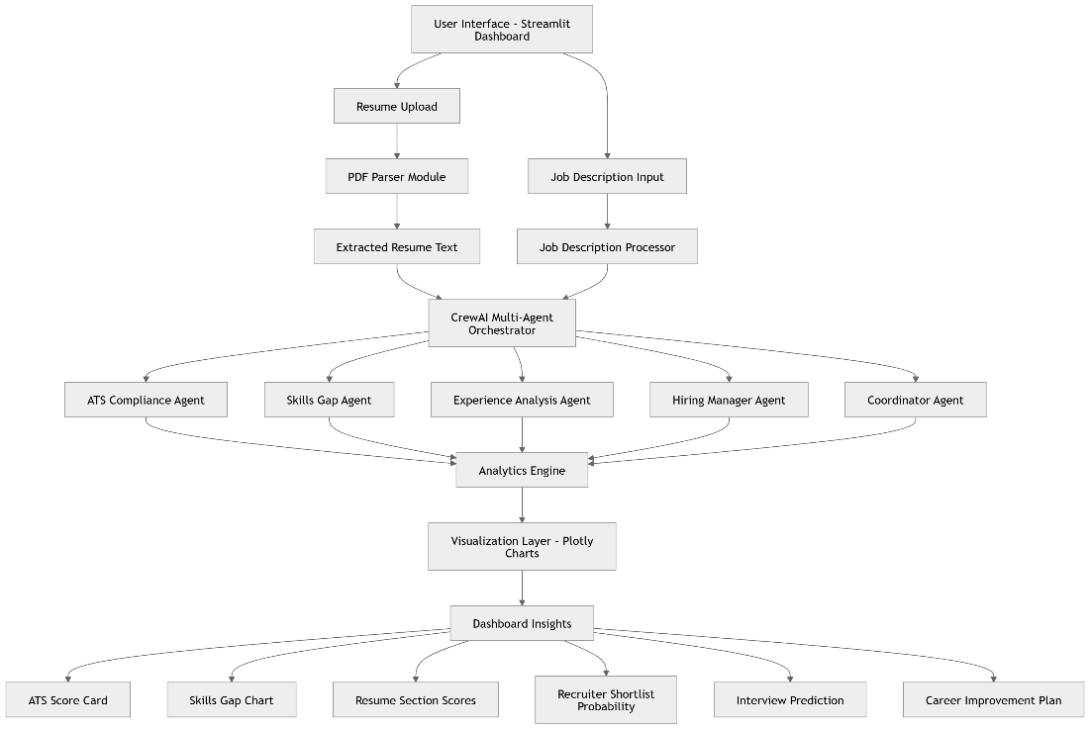

15. Data Flow Diagram
This diagram explains data processing inside the system.
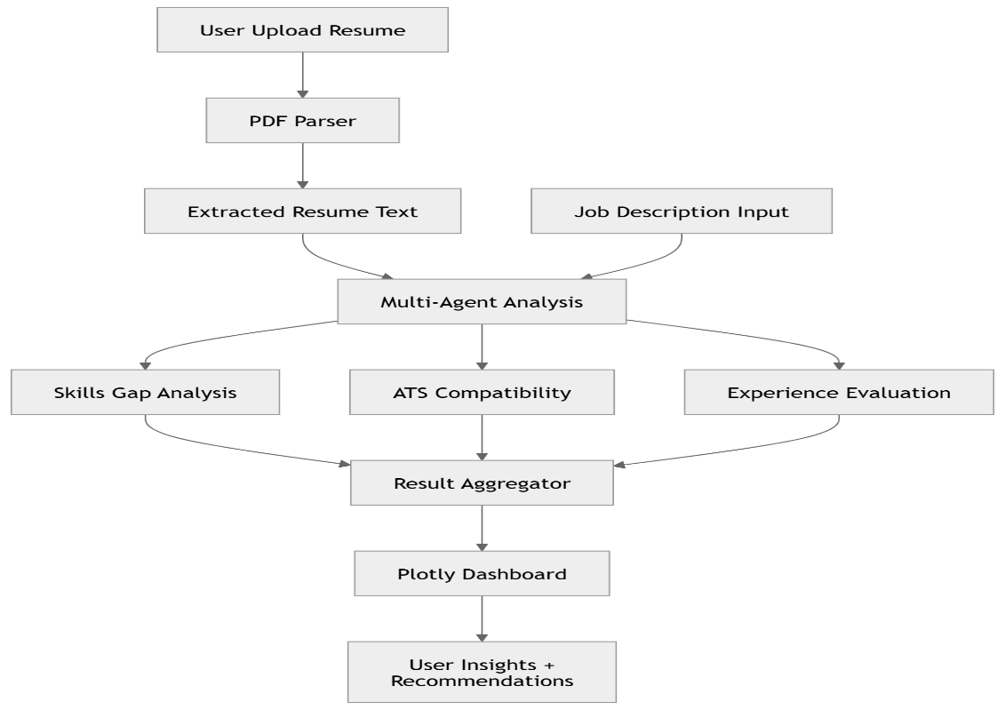
16. AI Agent Architecture
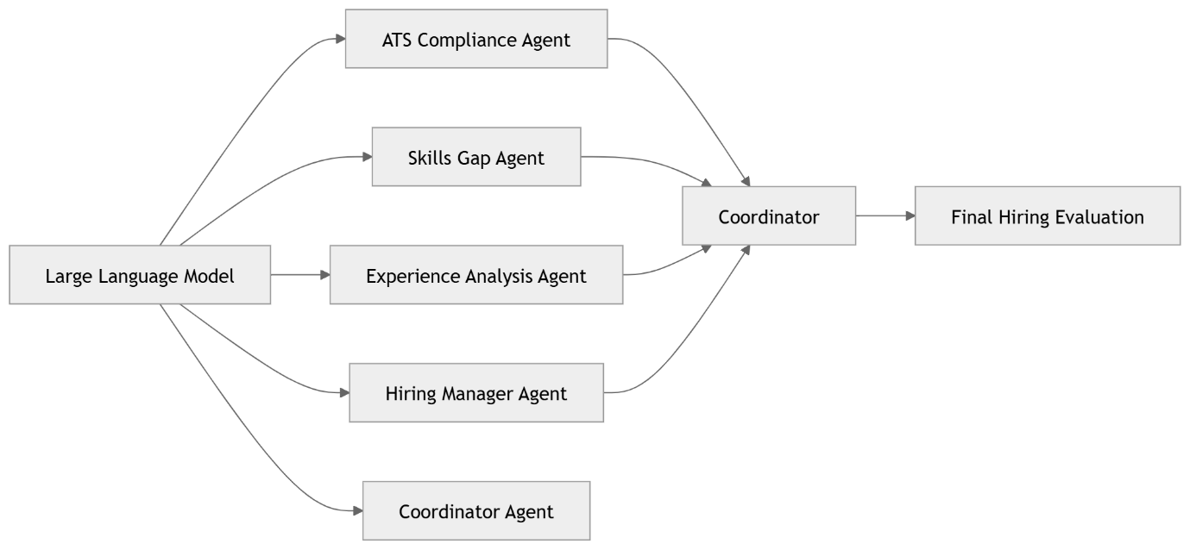

17. System Deployment Architecture
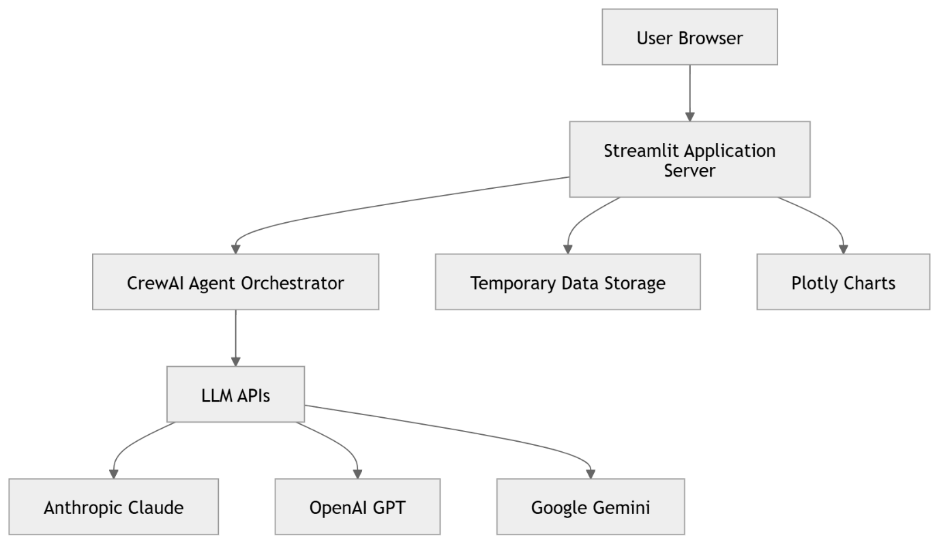

18. Conclusion
HireLens AI demonstrates how multi-agent AI systems can improve decision analysis in recruitment workflows. By simulating the hiring pipeline through specialized AI agents, the system provides deeper and more actionable insights for job seekers.
The project highlights the potential of agentic AI systems to solve complex decision-making problems in career development and recruitment technology.

